40 lb.
BAG

THE ECOSPONGE™ DIFFERENCE
- HIGHLY ABSORBENT

Quarts Absorbed per Bag

PACKAGING

MADE FROM RECYCLED, BEETLE KILL PINE TREES
MANUFACTURED IN THE USA
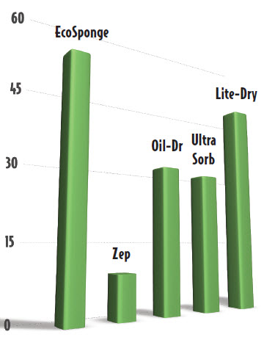
Low-Cost, Efficient & Dust Free
OUR COMMITMENT
We are committed to protecting our planet Earth by utilizing local, beetle kill pine and other waste streams to produce our products and by using our proprietary, sustainable, state-of-the-art manufacturing process. We are reducing our carbon footprint by 25% through the production of biochar, which sequesters carbon, and by deriving 50% our energy from renewable, biomass sources.
CONFLUENCE ENERGY — MAKING A GREEN PRODUCT EVEN GREENER.

EcoSponge™ is a dehydrated, densified cellulose fiber product specifically designed to absorb oils, solvents and other contaminants. Our proprietary product was engineered to be oleophilic and can be used on soil and hard surfaces. EcoSponge™ can absorb 4 to 8 times its volume in most absorption applications.
Based on third party testing by Emory Labs environmental and biotechnology scientists at the University of Colorado, EcoSponge™ absorbs up to 7X more oil per $1spent than other brands.

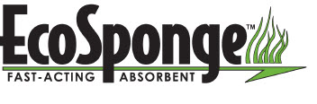
ConfluencyEnergy.com
970.724.9839



